Contact Details

Physical Address:
112 Corks Road, Tikipunga,
Whangarei.

Postal Address:
PO Box 7027
Tikipunga
Whangarei, 0144

Telephone: 0800 004 001 or 09 438 7771

Email Address:
northland@alzheimers.org.nz

Website Address: www.alzheimers.org.nz/northland
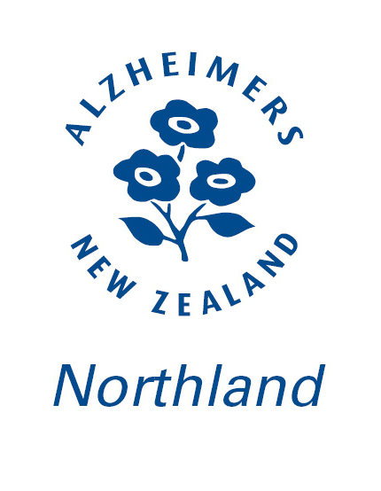

Services the Alzheimers Society provides includes: Home Visits, Rural Day Centre, Support Groups and Seminars. Please contact the Society for further information on support services available.
Alzheimers Society Northland

Services Provided

The Alzheimer’s Society Northland is a not-for-profit organisation which provides support, information, and education to anyone in the Northland Community who is affected by Alzheimers Disease and/or a related Dementia, their family and whanau.

All contact will be kept strictly confidential. We have offices in Whangarei, Kerikeri and Dargaville.

We have seven Community Advisors working throughout Northland. You can visit www.alzheimers.org.nz/northland to see who they are and the services they provide.

Day Care

Alzheimers Society Northland Inc runs Day Care programmes in Whangarei, Waipu and Paihia. The Society has staff that provides supervision and activities for people with dementia.

‘Alz Club’ provides a “fun day out” for the person with dementia and a “day off” for the Caregiver.
Please contact our Community Advisors for details on referral to this service.

Carer Education Seminars

Alzheimers Society Northland Carer Education Seminars are designed to give the Home Carer an understanding of dementia, some of the problems they may encounter and ways of coping with them and the many other changes they and their loved one may be experiencing.

Please contact the office for details on when the next seminar will be held in your area.


The values of Alzheimers Society Northland (Inc.) are: Accessibility, Leadership, Zest, Holistic approach, Equality, Inclusion, Motivation, Empathy, Respect and Support.
Linking disability information to people
and families in Northland
tiaho.org.nz

