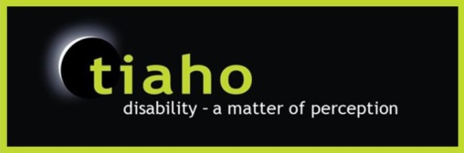
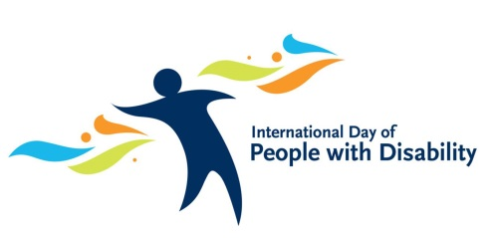

International Day of People with Disabilities
“Celebrating Abilities”
Friday 7th December 2018 – 10am-2pm
Canopy Bridge & Carpark area
Town Basin, Whangarei
*** NZSL INTERPRETERS WILL BE IN ATTENDANCE ***

10.00am Himene / Karakia – Wiremu Kani
Welcome by Jonny Wilkinson CEO, Tiaho Trust – thanks to sponsors
Official Opening: (Mayor – Sheryl Mai)
MC: Dave Wright

10.30am [Dave to let everyone know about the Activities – Lynkz activities, Sport Northland, Bunnings, etc
11.00am Karen Taylor from (Idea Services) & Pascifika Group
11.15am Circus Kumarani
11.30 am Ming Ming
12.00pm Natalia Weir
12.30pm Background music by Dave Wright
1.00pm Strongbeats Dance Crew
1.15pm Alice Cov-Smith
1.20pm Kind Hands – Introduction to Service they provide
1.30pm Open mic / getting people involved in activities
2.00pm Closing
MC -Dave - Notes
Introduce speakers/acts
Talk to Stallholders
LYNKZ – Talk to them of what activities
Papermill – and Bunnings workshop
Hikurangi Lions – food available

